Financial Forecasting
using System;

namespace FinancialForecasting
{
class Program
{
static double Forecast(double currentValue,
double growthRate,
int years)
{
if (years == 0)
return currentValue;

return Forecast(
currentValue * (1 + growthRate),
growthRate,
years - 1
);
}

static void Main(string[] args)
{
double presentValue = 10000;
double growthRate = 0.10;
int years = 5;

double futureValue =
Forecast(
presentValue,
growthRate,
years
);

Console.WriteLine("Present Value = " + presentValue);
Console.WriteLine("Growth Rate = " + (growthRate * 100) + "%");
Console.WriteLine("Years = " + years);
Console.WriteLine("Future Value = " + futureValue);
}
}
}
Output

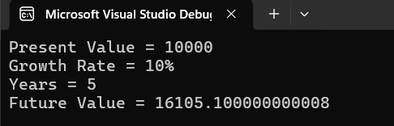
Analysis

Recursion

Recursion is a programming technique in which a function calls itself to solve a problem. A recursive function must have a base condition that stops the repeated function calls. Recursion helps break complex problems into smaller and simpler subproblems.

In this exercise, recursion is used to calculate the future value of an investment by applying the growth rate repeatedly for a specified number of years.

Working of the Algorithm

The function starts with the present value and applies the growth rate for one year. It then calls itself for the remaining years until the number of years becomes zero. When the base condition is reached, the final calculated value is returned.

Time Complexity

The recursive function makes one recursive call for each year. Therefore, if the forecast is calculated for n years, the function executes n times.

Time Complexity: O(n)
Space Complexity: O(n) due to the recursive call stack.

Optimization

For a small number of years, recursion works efficiently. However, for a large number of years, repeated function calls increase memory usage. The solution can be optimized by:

- Using an iterative approach with loops.
- Applying dynamic programming or memoization.
- Using the mathematical formula directly to calculate future value.

